Electrocatalytic Properties of Sb₂Se₃ Thin Films for Water Electrolysis

Vusala Majidzade¹, Sevinj Javadova¹, Samira Jafarova¹, Sh.O. Eminov², Akif Aliyev¹
and Dilgam Tagiyev¹
¹Institute of Catalysis and Inorganic Chemistry, Baku, Azerbaijan
²Institute of Physics, Baku, Azerbaijan

Water electrolysis is the most attractive method for obtaining environmentally friendly hydrogen. As you know, during the electrolysis of water, water molecules are separated into hydrogen and oxygen molecules using a current flowing through water. This process requires quite a lot of energy, so the use of electrocatalysts can significantly increase the efficiency of this process.

Research is often carried out in the field of electrocatalysis of metal chalcogenides as a cathode in the electrolysis of water [1]. In particular, antimony selenide (Sb₂Se₃) [2] is a semiconductor material that has been studied as a potential electrocatalyst for hydrogen evolution during water electrolysis. The electrocatalytic properties of Sb₂Se₃ thin films during water electrolysis have been studied in several studies. These studies have shown that Sb₂Se₃ exhibits good catalytic activity in the hydrogen evolution reaction (HER). The researchers attributed this activity to the high conductivity and good stability of the Sb₂Se₃ film.
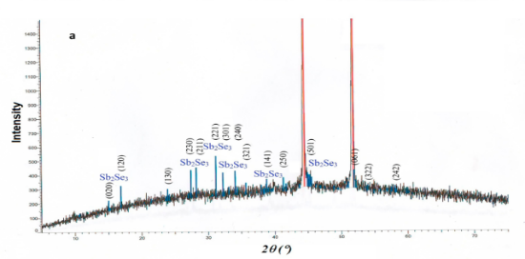

Fig.1 . X-ray phase analysis of Sb₂Se₃ thin films

In general, the electrocatalytic properties of Sb₂Se₃ thin films in the electrolysis of water open up prospects for the development of efficient and stable cathodes in the process of water and hydrogen ion reduction. However, more research is needed to optimize the synthesis and performance of this material.

For the study of the electrocatalytic characteristics, thin Sb₂Se₃ semiconductor films were obtained by electrochemical deposition from an aqueous and organic electrolyte with a tartrate additive. The samples were obtained on a nickel substrate with an area of 2 cm². XRD pattern of Sb₂Se₃ is shown in Fig.1

Catalytic studies of Sb₂Se₃ thin films were carried out in a neutral medium (0.5 M Na₂SO₄). The polarization curves were recorded in an IVIUMSTAT Electrochemical Interface potentiostat (Ivium Technologies). A glass three-electrode electrochemical cell with a volume of 100 ml was used. To compare the catalytic activity of different substrates, Ni with an area of 2 cm², Pt with an area of 0.35 cm², and samples of heat-treated Sb₂Se₃ films with an area of 2 cm₂ were used. The auxiliary electrode used is a platinum plate with an area of 4 cm₂. The reference electrode was a silver chloride electrode – (Model No. CS901, CorrTest Instruments).
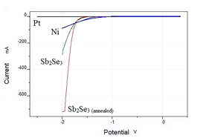

Fig.2 Electrocatalytic activity of synthesized Sb₂Se₃ thin films in a neutral medium (0.5 M Na₂SO₄).

As can be seen from Fig.2 compared with other cathodes, annealed Sb₂Se₃ has high electrocatalytic activity. Annealing of samples on a nickel electrode was carried out at a temperature of 723 K, in an atmosphere of inert gas - argon 70 minutes. The increase in electrocatalytic activity is due to changes in the structure of the studied material during heat treatment. This can lead to an increase in the number of active sites, or reduce the impurities' content and improve the material's crystal structure.
Acknowledgment
The study was ﬁnancially supported by the National Academy of Sciences of Azerbaijan within the framework of research programs in priority directions in 2019–2022.

References
- Marsagishvili, T.A. et al. Chemical Problems, 19, 7-17 (2021)
- Majidzade,V.et al. Chemical Problems, 18, 181-19 (2021)

